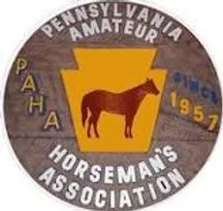
Pennsylvania Amateur Horseman’s Association

Pahahorseshows@gmail.com

www.pahainfo.net

Dear Sir or Madame,

The Pennsylvania Amateur Horseman’s Association (PAHA) is a family organization comprised of a wide variety of horse enthusiasts. PAHA is classified as a non-profit organization under 501 c(7). Our organization is currently looking for sponsors to help cover operating costs of our local horse shows. We would love to add you to our list of elite donors.

As an organization, we put on affordable horse shows in Butler and Lawrence counties in PA. Our show season consists of 16 horse shows during the summer which are attended by approximately 300 or more people from the tri-state area. The funds are used for various activities such as prizes for classes, enhancing venues where we show, upgrading our announcing and technology capabilities, and automating our entry booth.

If you are interested in sponsoring, please see the attached sponsorship form for more information on the different levels of participation. Should you have any questions or concerns, please do not hesitate to contact a PAHA officer or board member. Additional information regarding the organization as well as contact information can be found at www.pahainfo.net. While visiting the website, please look at our sponsor’s page, it is a great, inexpensive way to promote your business.

We would greatly appreciate your help and support in providing bigger and better horse shows for the 2023 season.

